If the distance between consecutive whole numbers on a number line is divided by tick marks into 10 equal units, then numbers corresponding to these marks can be named using decimal numbers with one decimal place

If each centimeter on a centimeter scale is divided into 10 equal parts, the each part is 1 millimeter long. Each part is also one tenth of a centimeter long.

Example 1.
Find the length of this segment:
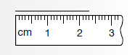

a. in centimeters
b. in millimeters

Solution:
a. 2.3 cm
b. 23 mm

Question: What number is in the ones place in 2.3? 2 What number is in the tenths place? 3

If the distance between consecutive whole numbers on a number line is divided into 100 equal units, then numbers corresponding to the marks on the number line can be named using two decimal places. For example, a meter is 100 cm. So each centimeter segment on a meter stick is 0.01 or $\frac{1}{100}$ of the length of the meter stick. This means that an object 25 cm long is also .25m long.

Example 2.
Find the perimeter of this rectangle in meters
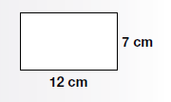

Solution:
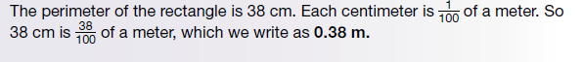

Example 3
Find the number on the number line indicated by each arrow.
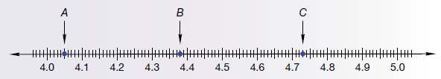

Question: On this number line, the shorter tick marks indicate what measure?
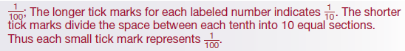

Solution:
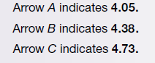

Example 4
Arrange these decimal number in order from least to greatest.
4.5, 4.25, 4.81

Solution:

You Try:
Use the following figure to answer the questions a and b:
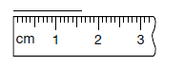
a. Find the length of the segment in centimeters. 1.6 cm
b. Find the length of the segment to the nearest millimeter. 16mm

CW: 8, 11-13, 15, 26, 28, *14, 1, 4, 7, 18, 27

HW: 1-7, 9-10, 14, 16-25, 27, 29-30

